NAV Bar

<https://stackblitz.com/angular/rdvljoqyyao?file=app%2Fsidenav-responsive-example.ts>

<https://stackblitz.com/edit/responsive-menu-angular-material-flex-layout?file=src/app/app.component.html>

Angular New application :

Make sure you have node and nps installed

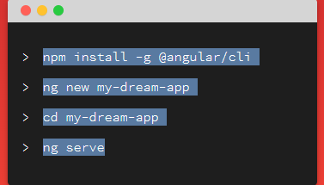

<https://cli.angular.io/>